Week 1 Analysis

# Ahmad Sarmad Ali

# Face Detection Models:

* I have researched upon different libraries that we can use for face detection.
* Found different models that we can use for face detection
* Harr Cascade
* YOLO
* Retinaface by Insightface. [Link](https://github.com/serengil/retinaface?tab=readme-ov-file)
* From all the above models I have found Retinaface very useful due to following resons

## Retinaface Features:

* As we can detect faces by using any face detector but what makes the retinaface stand out from others is it’s output format.
* Retinaface returns the output in the following format

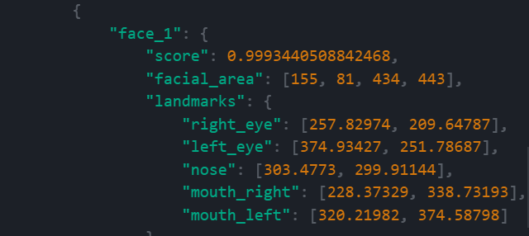

* As you can see it returns a dictionary having score and it also returns coordinates for different facial landmarks which is very helpful in applying filters.
* We can apply even **emotion based filters** by using these coordinates.

## Why Chose retinaface:

* We can of course train our custom model for that task but we need a data set for that I have also find a dataset for that as well. [Link](https://www.kaggle.com/c/facial-keypoints-detection/data)
* But training a custom model will not give us that good performance that we are getting from retina face.

# Emotion Based filter:

* I have implemented a emotion based filter application using retinaface.
* It applies a mostache filter on smiling.
* The coordinates of facial land marks that we get from retinaface makes it much easier (not that much easy).
* We can use Nose, eyes and mouth coordinates (upper and lower lip) to detect change in emotions and apply filters respectively.
* Although this is not best way I will discuss another method that I have found and we will use that which is much more efficient.

# Landmark detection:

* As I have discussed above with the use of retinaface we will be able to detect several facial landmarks which will be helpful in further processing.
* We will be using another method for emotion based filter application.
* I have already shared the format of landmarks above.

# Face Recognation:

* Face detection and recognition are two different things but don’t worry along with retinaface Insightface also provide a face recognition model.
* This model is Arface and it is also pretrained model with best accuracy nearly surpassing human accuracy. (according to creators)
* It gives 99% whiles humans give only 97%.
* We also have facility to use both retinaface and arcface together and they are wrapped in a single model Known as Deepface.
* Cool, isn’t it?
* So know we have best models for face detection and recognition.
* Although we can train a custom model for recognition as well

# Why pertained:

* I have already discussed above if we train a custom model we will not be able to get good performance as these pretrained models as they are trained on huge datasets giving good performance.

# Nest work to do:

* Another more efficient method that I was talking about for applying emotion based filter application is using a Neural network to detect emotions in each frame and they apply filters based on the output from the emotion predictor model.
* This method is way more efficient then the currently implemented method.
* One reason is that currently we are applying emotion based filters by guessing the change in coordinates of face which doesn’t work always as it have flaws.
* Now I am working to train a custom emotion detector model that can detect the emotions and then we can apply filters based on that.
* I have also found a useful resource for that as well. [Link](https://www.digitalocean.com/community/tutorials/how-to-apply-computer-vision-to-build-an-emotion-based-dog-filter-in-python-3#step-7-building-the-face-emotion-classifier-using-a-convolutional-neural-network-in-pytorch)

# Conclusion:

So, till now I have finalized best models for all three tasks face detection, recognition and landmark detection. I have also implemented a emotion based filter application but it is not that much efficient. Also found another efficient method for doing that. So, I will try to implement it in next week (IA).